WEEK 3
Crafting Interactive Data Stories
Retail Store Transactions — Tableau Data Storytelling Project
PROJECT FOCUS
Designing a coherent, sequential and interactive narrative that transforms retail transaction analysis into an accessible business story.

Prepared for: YUVA INTERN
Data Source: Retail Store Transactions
Platform: Tableau
Submission: Week 3 Dashboard Storytelling Plan

1. Executive Summary
This Week 3 project develops an interactive data-storytelling strategy for the Retail Store Transactions dataset analyzed during Week 1 and planned for dashboard implementation during Week 2. The purpose is not simply to display charts, but to create a logical narrative that helps a business user move from a high-level understanding of retail performance to focused investigation.
The proposed story begins with four KPI cards that establish context, continues with the chronological Year-Month Sales Trend to show how performance changes over time, and then moves into product, location and payment analysis. Interactive filters, selections, tooltips and dashboard actions are planned so users can investigate the same business story at different levels of detail.
CENTRAL STORY
Overall performance provides the context; time explains when changes occur; product and location analysis explain where performance is coming from; payment analysis adds customer-behavior context; interactions allow users to investigate the areas that matter most.

2. Project Objective
The objective is to craft a complete interactive data story in Tableau that communicates retail sales insights in a sequential and engaging manner. The design connects visualizations so that each stage answers a natural follow-up question and prepares the audience for the next stage.
- Convert Week 1 exploratory findings into a coherent narrative.
- Use the Week 2 dashboard blueprint as the structural foundation.
- Sequence visualizations from overview to detailed investigation.
- Define interactive elements that support exploration without creating visual clutter.
- Document the narrative clearly enough to guide later Tableau implementation.

3. Dataset and Analytical Foundation
Item | Project detail
Dataset | Retail Store Transactions
Records | 2,000 transactions
Date range | 1 January 2023 to 30 June 2025
Total sales | ₹2,207,643.55
Total quantity | 11,057
Average transaction value | ₹1,103.82
Products | Chair, Desk, Laptop, Monitor, Phone, Printer, Tablet
Locations | Store A, Store B, Store C, Store D
Payment types | Cash, Credit Card, Debit Card, Gift Card, Online

The story uses the cleaned transaction-level dataset prepared for the earlier project. The 2025 data covers January through June, so annual comparisons involving 2025 should be interpreted as partial-year results.

4. Target Audience
- Store Managers — need a quick view of performance and store-level differences.
- Sales Managers — need product and time trends to identify stronger and weaker performance areas.
- Business Managers — need a concise overview for decision-making and performance review.
- Business/Data Analysts — need interactive detail for deeper investigation and follow-up analysis.

5. Data Story Concept and Key Message
The proposed narrative is titled “Understanding Retail Store Sales Performance: From Overall Performance to Actionable Investigation.” The story is designed as a guided analytical journey rather than a collection of independent charts.

5.1 Central message
Retail sales performance is shaped by differences across time, products, locations and payment methods. An interactive Tableau story should allow decision-makers to start with the overall picture, identify meaningful patterns, and then drill into the dimensions that explain those patterns.

5.2 Supporting insights from Week 1
- Total sales across the dataset are ₹2.21 million from 2,000 transactions.
- Monitor is the highest-sales product at ₹347,995.64, followed closely by Phone and Printer.
- Store C has the highest sales among the four locations at ₹595,009.04.
- Debit Card has the largest sales contribution among the payment methods.
- The chronological trend should be used for the main time narrative because it preserves the sequence from January 2023 through June 2025.
- Potentially unusual high-value transactions were identified during EDA and can remain supporting analytical views rather than occupying the main story.

6. Storytelling Narrative and Visualization Sequence
Stage | Business question | Visual | Role in story | Transition
1. Establish context | What is the overall performance? | KPI cards | Creates an immediate performance baseline. | Move from “how much?” to “when?”
2. Discover change | How are sales changing over time? | Year-Month Sales Trend | Shows chronological pattern and periods of interest. | Move from “when?” to “what is driving performance?”
3. Compare products | Which products contribute most? | Sales by Product + Quantity Sold by Product | Compares revenue and volume across products. | Move to location context.
4. Localize performance | Where are sales strongest? | Sales by Location | Compares four stores and supports location-focused investigation. | Move to customer/payment context.
5. Explain payment behavior | How are customers paying? | Payment Mix | Adds payment-method context. | Move from summary to user-driven exploration.
6. Investigate | What should we explore further? | Filters, selections, tooltips and supporting EDA | Allows focused drill-down. | End with evidence-based investigation.

The sequence is intentionally progressive: context first, then change over time, then the dimensions that explain performance, followed by focused exploration.

7. Visual Storyboard
The storyboard below represents the intended narrative sequence. It is linear at the conceptual level, while the final Tableau dashboard remains interactive.
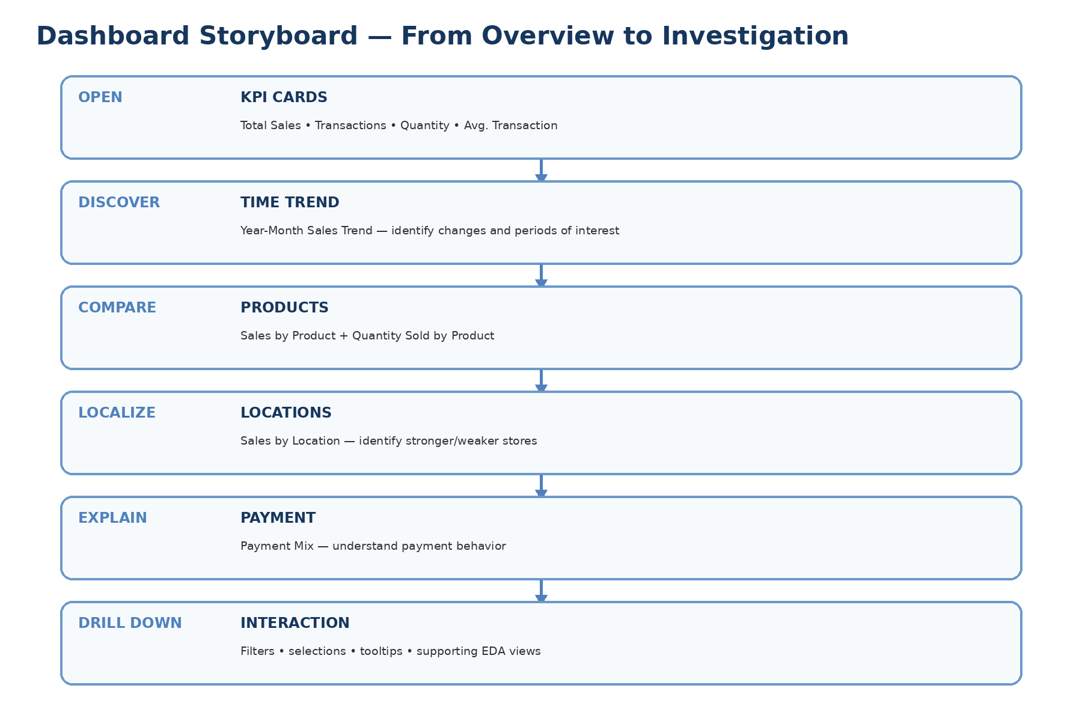

8. Interactive Data Story Flow
The interactive flow begins with a broad overview and progressively narrows toward investigation. The interaction design should support exploration without forcing users to learn complex controls.
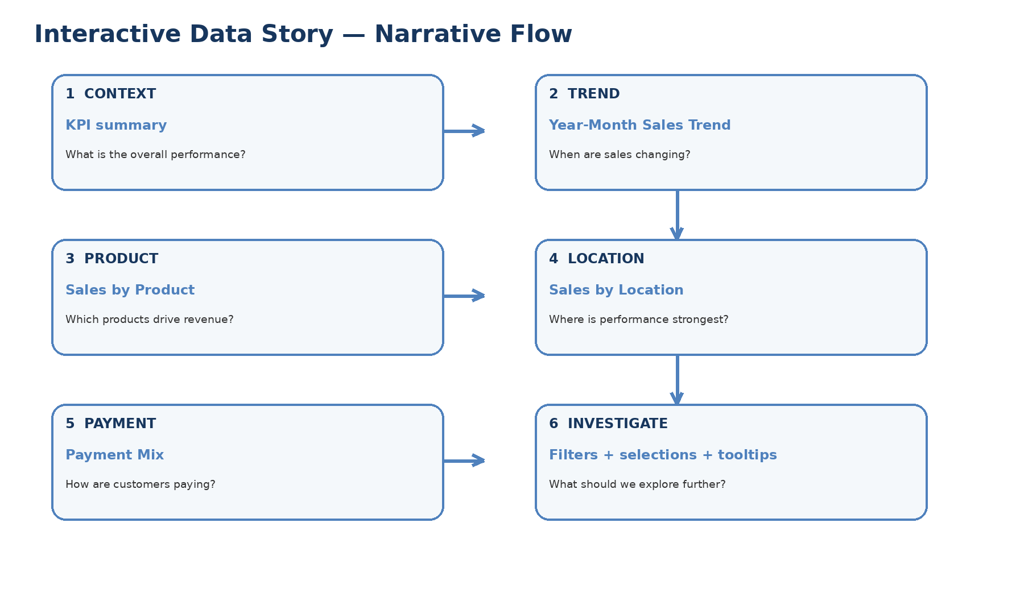

9. Interactive Elements Plan
Interactive element | Planned use | Narrative benefit | User outcome
Date / time filter | Filter to a selected period or year-month range. | Investigates when a pattern occurred. | Focuses the story on a relevant period.
Product filter | Select one or more products. | Connects overall performance to product evidence. | Identifies product-specific patterns.
Location filter | Select Store A, B, C or D. | Supports location-level investigation. | Shows whether a pattern is concentrated in a store.
Payment Type filter | Select a payment method. | Adds customer payment context. | Explains payment composition.
Chart selection / dashboard action | Selecting a product or location focuses related views. | Creates a connected story instead of isolated charts. | Enables drill-down.
Tooltips | Display precise values on hover. | Provides detail without clutter. | Lets users verify values quickly.
Highlighting | Emphasize the selected category across related views. | Maintains context. | Makes relationships easier to see.
Supporting analytical views | Use outlier and Unit Price vs Quantity analyses for deeper investigation. | Keeps advanced analysis available without overcrowding. | Supports follow-up questions.

10. How Interactions Support the Narrative
- Open the dashboard and review the KPI summary to understand the scale of activity.
- Observe the Year-Month Sales Trend to identify periods of stronger or weaker sales.
- Select a product that appears important and investigate it using the connected views.
- Compare the selected product or overall sales across Store A–D to determine whether performance is location-specific.
- Review payment mix to understand how transaction value is distributed across payment methods.
- Use filters and tooltips to answer a specific follow-up question without leaving the dashboard.
- If a pattern appears unusual, move to the supporting outlier or relationship analysis for deeper investigation.

11. Visualization-by-Visualization Story Role
Visualization | What the audience sees | Why it belongs in the story | Design intention
KPI Cards | Total Sales, Transactions, Total Quantity, Average Transaction Value | Establishes the baseline before interpretation. | High visibility, minimal text, immediate comprehension.
Year-Month Sales Trend | Chronological sales movement from Jan 2023 to Jun 2025 | Creates the time narrative and identifies periods of interest. | Continuous date axis and tooltip detail.
Sales by Product | Revenue comparison across seven products | Answers which products contribute most. | Ranked horizontal bars.
Quantity Sold by Product | Units sold by product | Adds volume context to revenue comparison. | Lets revenue and quantity be considered together.
Sales by Location | Revenue comparison across four stores | Shows where performance is strongest. | Simple comparison chart.
Payment Mix | Sales contribution by payment method | Adds behavioral context. | Compact composition view.
Supporting outlier view | Potentially unusual transaction values by product | Supports deeper investigation. | Secondary analytical view.
Unit Price vs Quantity | Relationship between price and quantity | Provides relationship analysis from Week 1 EDA. | Scatter plot for exploration.

12. Narrative Transitions
TRANSITION 1 — CONTEXT → TIME
After seeing the overall KPIs, the natural next question is whether sales performance is stable or changing. The Year-Month Sales Trend answers this question.

TRANSITION 2 — TIME → PRODUCT
Once a period of interest is identified, product analysis helps explain which categories contribute to sales.

TRANSITION 3 — PRODUCT → LOCATION
After identifying important products, location analysis helps determine where sales performance is strongest or weakest.

TRANSITION 4 — LOCATION → PAYMENT
Payment mix adds another dimension to the customer transaction story and helps contextualize sales activity.

TRANSITION 5 — SUMMARY → INVESTIGATION
Filters, selections and tooltips allow the audience to move from a general observation to a focused analytical question.

13. Color, Typography and Visual Design Strategy
- Use a restrained professional palette consistent with the Week 2 dashboard blueprint.
- Use blue/teal accents for headings, key analytical emphasis and interactive states.
- Use a light, uncluttered background to maintain readability.
- Use consistent chart titles written as business questions or clear analytical statements.
- Use sufficient white space so charts remain visually distinct.
- Use consistent number formatting for currency, counts and percentages.
- Reserve strong visual emphasis for the most important message rather than decorating every chart.
DESIGN PRINCIPLE
The visual design should make the narrative easier to understand, not compete with the data. Every visual element should have a defined storytelling role.

14. User Journey and Expected Experience
User action | Expected thought/question | Dashboard response
View KPI cards | What is the overall situation? | Provides immediate scale and baseline.
Scan sales trend | When did performance change? | Reveals chronological movement.
Compare products | Which products matter most? | Ranks product contribution.
Compare locations | Where is performance strongest? | Highlights store differences.
Review payment mix | How are customers paying? | Shows payment-method composition.
Apply a filter | Does this pattern remain for a specific category, store or period? | Updates relevant views.
Hover over a mark | What is the exact value? | Tooltip supplies precise detail.
Investigate an unusual result | Why does this observation look different? | Supporting EDA views provide deeper context.

15. Supporting Analytical Views
Not every analytical view should be placed in the primary narrative. The Week 1 outlier and relationship analyses are retained as supporting views because they address the requirement to examine unusual observations and relationships while avoiding visual overload in the main story.
- Transaction Value Outliers — useful when a user wants to investigate unusually high transaction values.
- Unit Price vs Quantity — useful for examining whether product price and quantity show a meaningful relationship.
- Day-of-week analysis — useful as a secondary view if future analysis requires weekday-level investigation.
This separation follows progressive disclosure: show the most important information first and make deeper analytical detail available when relevant.

16. Storytelling Techniques Used
- Progressive disclosure — move from summary to detail.
- Question-driven sequencing — each visual answers a natural follow-up question.
- Context before comparison — KPIs appear before detailed comparisons.
- Comparison before investigation — users first see the pattern, then explore its dimensions.
- Consistent visual language — the same measures, labels and formatting are used throughout.
- Interactive exploration — users can personalize the story without losing the overall structure.
- Focus and restraint — supporting analyses are available without overcrowding the primary narrative.

17. Innovation and Interactivity Strategy
The interactive design is intentionally practical rather than complicated. Innovation is defined as making interactions serve the narrative. Instead of adding controls simply because Tableau supports them, each interaction is linked to a business question.
- Cross-view selection: selecting a product or store can focus related analytical views.
- Context-preserving filters: filters narrow the story while keeping KPI and trend context visible.
- Tooltip storytelling: tooltips provide the next layer of detail only when requested.
- Supporting-view access: advanced EDA can be used when a user encounters an unusual pattern.
- Progressive investigation: the dashboard moves from observation to comparison to focused investigation.

18. Implementation Plan for Tableau
1.Create the KPI summary area using the measures defined in Week 2.
2.Place the chronological Year-Month Sales Trend as the primary analytical visual.
3.Add product, location, payment and quantity views according to the storyboard.
4.Create the planned filters and confirm that they update the intended sheets.
5.Configure dashboard actions/highlighting for product and location selections where appropriate.
6.Configure informative tooltips with sales, quantity and transaction context.
7.Test representative questions such as “Which product contributes most?”, “Which store performs best?” and “What happens during a selected period?”
- Remove or simplify any interaction that does not improve the story.
- Validate that the final dashboard remains readable and that users can understand the narrative without extensive instruction.

19. Evaluation Criteria Alignment
Evaluation criterion | How this project addresses it
Coherence and clarity of narrative design | A six-stage sequence moves from KPIs to trend, product, location, payment and investigation.
Innovative use of interactive elements | Filters, selections, highlighting, tooltips and supporting views are tied directly to business questions.
Depth of analysis and planning | The document explains the purpose, role, transition and interaction strategy for each visual.
Ability to convey a complete data story | The storyboard creates a beginning, analytical middle and investigation-focused ending.
Thoughtful storyboarding and interactive design | Two diagrams, visualization sequence tables and user-journey documentation make the intended experience explicit.
Accessibility of insights | Clear titles, restrained formatting, progressive disclosure and interactive detail support understanding.

20. Risks, Limitations and Design Controls
- 2025 contains only January–June data; the story should not imply a full-year 2025 comparison.
- Some measures are mathematically related because Total Price is derived from Quantity and Unit Price.
- Too many filters can distract from the narrative; only the most useful filters should be prominent.
- Too many charts can weaken storytelling; supporting EDA views should remain secondary.
- Interactive actions should be tested carefully to avoid confusing states.
- Potential outliers should be described as observations requiring investigation, not automatically as errors.

21. Final Story in One View
THE COMPLETE STORY
Start with “What is our overall performance?” → move to “When is performance changing?” → ask “Which products are driving it?” → ask “Where is it happening?” → add “How are customers paying?” → finish with “What specific pattern should I investigate?”

This structure ensures that the dashboard is not simply a collection of charts. Instead, it becomes an interactive analytical conversation in which every visualization prepares the audience for the next question.

22. Conclusion
The Week 3 plan converts the findings and dashboard design work from the previous stages into a coherent interactive data story. The proposed narrative starts with an accessible performance summary and gradually introduces time, product, location and payment dimensions before allowing the user to investigate specific patterns through interactions.
The design balances guided storytelling with user freedom. The core sequence provides a clear path for first-time users, while filters, dashboard actions, tooltips and supporting analytical views provide depth for users who want to explore further. This approach is intended to make the final Tableau dashboard engaging, business-focused and easy to understand.

